Annual Report
2021

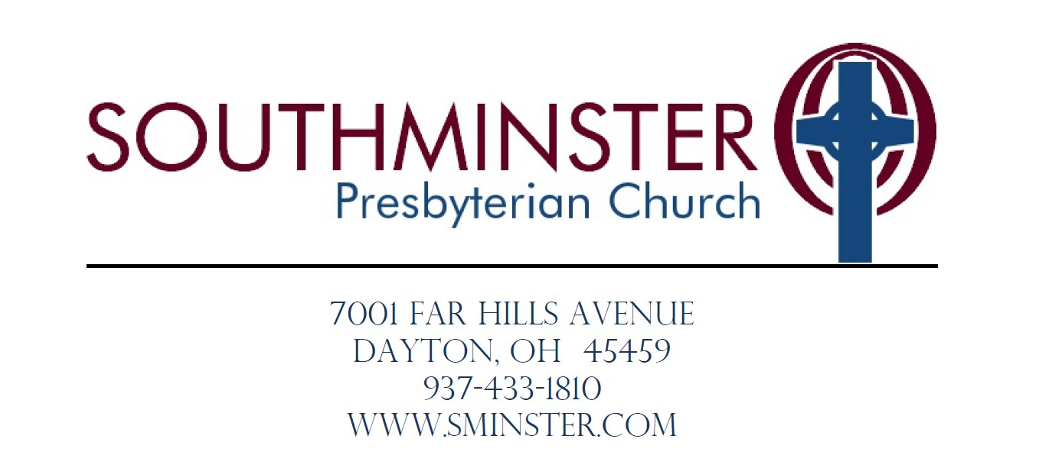

Table of Contents

Pastor/Head of Staff…………………………………………………………………………………………3
Previous Minutes…………………………………………………………………………………………….7
Membership Report…………………………………………………………………………………………10
Finance Team
Budget……………………………………………………………………………………………….…11
Finance Report………………………………………………………………………………………..12
Treasurer’s Report……………………………………………………………………………….…..13
Stewardship Team……………………………………………………………………………………………14
Christian Education Team……………………………………………………………………………..….. 14
Children and Youth…………………………………………………………………………………………..14
Nominating Team…………………………………………………………………………………………….16
Worship Team…………………………………………………………………...……………………………16
Mission Team…………………………………………………………………………………………………17
MarCom Team………………………………………………………………...………………………………19
Invitation Team……………………………………………………………………………………………….20
Building and Grounds Team……………………………………………………………………………….21
Personnel Team………………………………………………………………………………………………22
Report of Compensation……………………………………………………………………………………23
Deacon’s Team
Fellowship……………………………………………………………………………………………..21
Prayer and Presence…………………………………………………………………………...……24
Church Officers……………………………………………………………………………………………….25

Pastor / Head of Staff
Back in January, when I was disappointed about COVID keeping us from having the Epiphany Feast for the second year in a row, it occurred to me that the wisdom of the Magi could help us navigate the challenges of being a church in a pandemic. Those travelers of old had a long, difficult journey to find the Christ child. They followed a star and believed that their seeking was not in vain, even after encountering the treacherous Herod. When they found Jesus, they went home by a different road. Herod was still looking for them, and their circumstances had not changed. However, they had changed.

The journey of faith isn’t always an easy one. We sometimes run into unexpected roadblocks and travel through wilderness places. Perhaps we can learn something from the Magi’s faithful journey from a far-away land to the tiny town of Bethlehem, where they knelt in awe before the baby in the manger. If we seek to follow and to keep Christ as the heart of this church, we will be filled with abundant hope and an awareness of the Spirit of the living God moving among us. We might even find a new and better road forward as a congregation.

With that said, churches have had a lot with which to deal in these last 2 years. In March of 2020, our way of being together in community was suddenly upended by the quarantine, and we had to pivot to livestream. On unsteady feet, I learned to preach to a camera and then to puppets and stuffed animals holding your places in the pews. We started having meetings, classes, and fellowship by Zoom, doing anything outside that we could, and checking up on each other by phone. In March of 2021, we had a service of “Lament, Remembrance, and Hope” as we thought about and prayed for those who had died in that first year of the pandemic.

By spring, most of our congregation was vaccinated, and we could again have in-person worship services. How wonderful it was to see your actual faces in the pews! We celebrated Heritage Sunday and even had liturgical dancers in an exciting Pentecost service. Things seemed to be going so well that we made masks optional. Then came Delta and Omicron, and the masks came back on. Now, we are hopeful for a time when masks will no longer be required.

I want to sincerely thank our staff, Deacons, Elders, volunteers, safety team, and the whole congregation for navigating the twists and turns in the road with such grace during this uncertain time. What is really astounding is that, in going through this together, we discovered some strengths that we may not have recognized in the past. I’m reminded of a line in Terence Blanchard’s opera, Fire Shut Up in My Bones. The line goes, “We Bend, We Sway, We don’t Break, Our Roots Run Deep.” I guess Southminster Presbyterian Church could add to that line, “We adapt and pivot!”

Often, change is initially experienced as loss. Some of the changes we have faced, have been particularly sad and frustrating. We long to have more indoor fellowship events, potluck dinners, big hugs, and the smiles that are too easily hidden under our masks. What has not changed and will never change is God’s faithfulness to us. We draw our strength from our deep roots – from confidence in the unfailing presence of the living God, from our history of life-changing ministry, meaningful worship, community service, faith formation for all ages, and genuine care for one another and our world.

There are many ways that we have been blessed in the mission and ministry of Southminster Presbyterian Church in 2021!

We have been blessed in our worship.
Under the direction of Ruth Whatley and accompanied by Jim Pera and other instrumentalists, our full choir, vocal ensemble, soloists, and bell choir have offered beautiful, inspirational, and sometimes jazzy music to lift our hearts to God in praise. The music for the Easter service and for the Advent service of Lessons and Carols was amazing. Some folks told me that they were brought to tears.

Our worship team came up with ever-new ways to enhance our experience by decorating the Sanctuary in ways that highlight the seasons and special days of the church year. Talented congregation members participated in dramas that I wrote for the Sunday after Christmas and for Maundy Thursday. Volunteer liturgists, those who prepare communion, greeters, ushers, and our fantastic Stream Team have helped us to offer worship both in-person and by livestream. Did you know that the total number of people in worship since we began having both options is often more than before the pandemic?

We have been blessed in our ministries of education and faith formation.
With the leadership of our former Associate Pastor, Rev. Laura Nile Tuell until June of 2021, and with the leadership of Josh Sweeney ever since that time, our youth group has been engaged in meaningful discussions, adventures, and service. Josh and many dedicated volunteers offered an excellent VBS experience. Having 65 kids with cicadas flying around was quite an adventure with squeals, a few tears, and plenty of laughter. A summer to remember! Our young people also enjoyed Sunday school, a children’s program called, “Godly play,” and a new fellowship group for 4th and 5th graders. Trunk-or Treat brought happy children to Southminster and gave adults a good excuse to get in costume!

Adults were involved in small groups during Lent and Advent, engaged in some special discussion Zoom opportunities, and had both online and in-person options for Bible study and for a social justice book club.

We have been blessed in our ministries of care and fellowship
While I believe that pastoral care is my strongest gift for ministry, the sense of warmth and caring in this congregation is mostly due to the compassionate efforts of our Deacons, Care Connection callers, Stephen Ministers, home communion servers, and prayer chain participants. Members also find their own ways of caring for one another. When someone is sick or grieving, they receive phone calls, cards, and sometimes even meals. Especially during these last 2 years, it is touching to witness all the ways that you support and encourage one another. Whenever we have been able to have outdoor events, our Fellowship Team has helped us with food, drink, welcome, and ideas for activities. Britt Platt was the primary organizer of a women’s retreat last fall, and it was so rejuvenating to be together for it that we didn’t want it to end!

We have been blessed with opportunities for mission and service.
Southminster's annual “The Church Has Left the Building” day of service included ten projects around the community. After so much social isolation in 2020, it was exciting to see such a large percentage of the congregation involved in hands-on work again. (See the Mission Report for more details.) We are in the planning stage of a new mission project, “Helping Hands,” through which we hope to offer home repairs for elderly people whose need is identified for us through the Agency on Aging. We have installed an outdoor blessing box as an extension of our food pantry and hope to begin installing them in other areas around Dayton.

We have been blessed with a dedicated staff.
Last November, at our staff retreat, there were a lot of comments about how much they enjoy working with each other, with the volunteers, and with this congregation. I am grateful that we have such a dedicated and talented staff!

In 2021, we said good-bye to our Associate Pastor, Rev. Laura Nile Tuell. She will especially be remembered for the many ways she used her technological and creative skills to help congregation members of all ages continue to connect with one another. On March 15 of 2022, we look forward, with delight, to welcoming back the Rev. Steve Schumm to Southminster. As our new Stated Supply Associate Pastor, he will bring some added energy, intelligence, imagination, and love.

Early in 2021, our Property Tech, Christian Zennie, left us for another job, and his humble, kind ways will also be missed. How excited we were when we found out that Jimmy HoShue missed us and wanted to come back to be our Property Tech! His knowledge, positive attitude, and sense of humor are greatly appreciated.

Our newest addition to the staff, Katie Rice, joined us in early December as our Marketing and Communications Manager. She is working well with the MarCom Team and coming up with good ideas for ways that we can help spread the word about all that is best at Southminster! When a large family saw her promotion of a hammered dulcimer player being a part of the Christmas Eve service, they came to church and took up a whole pew!

For 14 years, Sharon Ark, our business and financial administrator, has shared her skills, dedication, and warm personality with us. For 10 years, Jenny Miller has welcomed little ones into the nursery, and high school senior, Caroline Adkins, has added her considerable skills in childcare as a second nursery employee. With a cheerful smile, Jerry Craig helps all of us on Sunday mornings as she opens the church and takes care of the needs of the congregation and the staff.

We have had both financial blessings and challenges
In 2021, we met our financial needs because of your generosity. We were also helped along quite a bit by a one-time grant from the government stimulus program and by the fact that we were not paying an associate pastor for half of the year. As we head into 2022, we have some definite financial challenges. Our Stewardship Team, along with other helpers, is already working toward some ideas in the hope of helping us toward a better financial outlook.

Visioning for the future.
It seems like, right now, the world is a troubled and contentious place with too much heartbreak. At the same time, it is a beautiful world– filled with people who love and care for one another and even make sacrifices for each other. What we do, as a church of Jesus Christ, has eternal significance as we recognize the need for the Good News of God’s unconditional love.

At our Session retreat last November, we used a process from the book called “A Beautiful Constraint,” by Mark Barden and Adam Morgan, to help us look at some of the best ways to move forward as a church. People think of a constraint as a negative thing that holds us down or holds us back, but the opposite can be true. It can be a catalytic force that makes us re-imagine something in a way that would not otherwise have occurred to us as a possibility. Our elders listed compelling questions from different areas of church life, mission, and ministry. After considering some of the constraints that could get in the way, they let those constraints lead them to better questions. Now we are thinking creatively of possible ways to answer those questions.

Although the pandemic brought challenges to the church, it also resulted in some things that we want to continue. For example, we want to keep livestreaming the worship services. It has brought new people to church, offered a way for homebound members to be a part of worship, and even provided an opportunity for families to see the same service and talk about it afterwards! There are positive things we learned about our strength and resiliency, and things we now know we want to do differently.

As our Seed Gathering Committee and Invitation Team already realize, in today’s world, we can’t just open the doors and hope people come into the church. While we will continue to reach out to the community in mission and service, we also need to connect in other ways. The Seed Gathering Committee has shared some of their ideas with appropriate teams, and folks on the Invitation Team continue to seek out new opportunities as well. If you have any ideas for us, please contact Andrea Calim or Jean Gaffney. If you were once a part of the Centerville school system as a student or faculty member, please reach out to Josh Sweeney or to me. We would like to gather you together and brainstorm some ideas about how to support school activities.

As we move to warmer months, we hope to have some new outdoor activities to get people together without the need for masks. When the numbers of Covid cases get low enough that you would feel safe coming back to in-person worship, I would urge you to join us! Yes, it is tempting to stay home and keep watching the livestream in your PJs, but then you are missing the connection and community that are so essential to being a part of a church family. When you aren’t here, we don’t feel like our family is complete!

I feel blessed to serve as your pastor, and I am grateful for all the ways we are engaged in ministry together. Thank you for your faithfulness to the Gospel, your care for each other, your willingness to open your hearts to learn and to grow, and for all the ways you inspire me and one another. As I see the light of Christ shining in and through you, it gives me hope for this world.

Peace and blessings,
Nancy

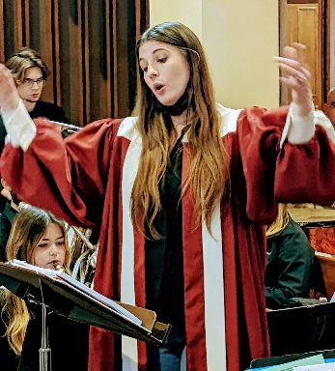
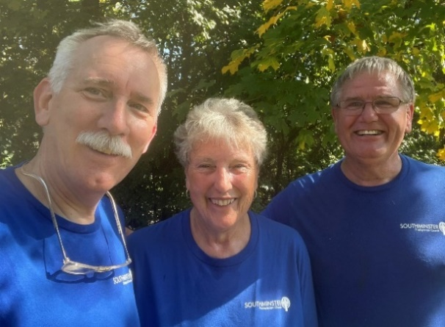
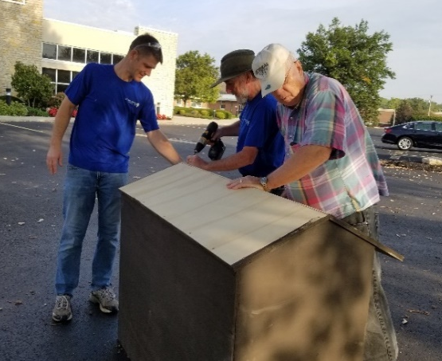

The Church Has Left The Building The Church Has Left The Building Lessons and Carols

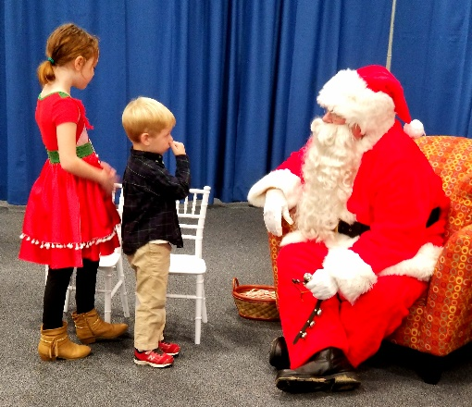
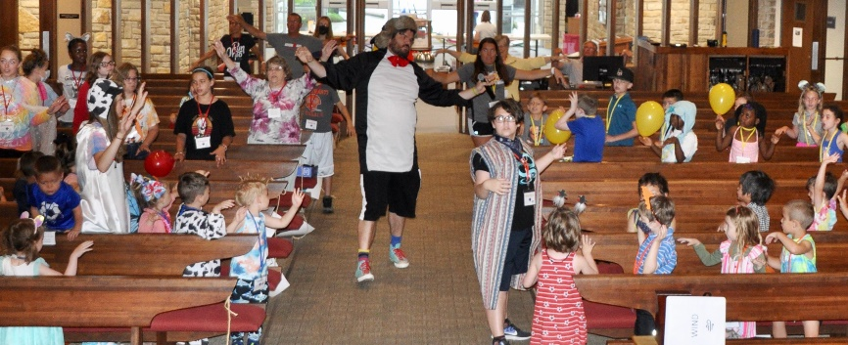

Vacation Bible School Breakfast with Santa

Southminster Presbyterian Church
Minutes of the Called Congregational Meeting
February 7, 2021

Meeting via ZOOM was Called to Order
by Rev. Dr. Nancy Birdsong, who opened with prayer at 11:38AM. There were 53 members in attendance, which represented a quorum, plus 3 Staff.

Pastor Nancy asked for a motion to revise the agenda by moving items into the correct order, as outlined in the Book of Order. MSA

Approval of Minutes:
Called Congregational Meeting of December 6, 2020 MSA
Brief Presentations by Pastors:
Rev. Dr. Nancy Birdsong
Rev. Laura Nile Tuell

Clerk’s Report: There were no changes or discussion of report as posted in the Annual Report pg. 24.

Memorial Moment: Pastor Nancy offered prayer for all those of our church family who had passed away in 2020

Session Team Reports: (in order as presented in Annual Report)
Invitation: Tom Novak- Chair:
Mission: Pete Garland-Chair:
Children’s Ministries: Josh Sweeney–Director
Christian Education: Karen Locke-Chair:
Building & Grounds: John Woods–Chair:
MarCom: Todd Hall-Chair:
Stewardship: Kathy Jester-Chair:
Personnel: Ron Kuker-Outgoing Chair
Finance: Ryan Battelle-Chair:

Deacon Team Reports:
Prayer & Presence: Judy Murphy – Chair:
Compassion & Assistance: Jan Hohenstein-Outgoing Chair:
Fellowship: Sandy Stevens-Outgoing Chair:

Revised 2021 Budget: Chair of Finance Ryan Battelle,

Presentation of Terms of Call for the Pastors: Personnel Chair: Irene Mathis: The Presbytery had recommended that there be no increases in Pastors’ salaries for 2021. The Terms of Call for Rev. Dr. Nancy Birdsong, Pastor/Head of Staff, and for Rev. Laura Nile Tuell, Associate Pastor were approved as presented in Annual Report pgs. 19-20. MSA.

Presentation of Revised Budget: Finance Chair: Ryan Battelle: The proposed revision for 2021 is for a balanced budget, as approved by Session at the January 26, 2021 meeting. MSA.

Closing Prayer for the Meeting of the Congregation: Rev. Dr. Nancy Birdsong
--------------------------------------------------
Opening Prayer for the Meeting of the Corporation: Kathy Jester, President
Election of Officers of the Corporation:
For President: Kathy Jester For Vice President: Janice Young For Secretary: Lois Thorp For Treasurer: Patty Izor MSA
Other Business before the Corporation: None
Meeting Adjourned with prayer by Pastor Laura Nile Tuell at 12: 24PM.

Southminster Presbyterian Church
Minutes of the Called Congregational Meeting
April 25, 2021

Meeting via Zoom was called to order at 11:43 a.m., by Rev. Dr. Nancy Birdsong, who opened with prayer. There was a quorum in attendance, plus 2 staff.

Elder Gretchen Cleaves, on behalf of Session and the Nominating Team, presented this motion: “To elect Liz Ferguson as a Ruling Elder to serve on Session and as Chair of the Personnel Team, filling the vacated term of Irene Mathis.” MSA
(Explanation: Irene felt she needed to devote more time to the care of her husband and his health.)
Liz was then Ordained and Installed

Meeting Adjourned at 11:58 a.m. with prayer by Rev. Laura Nile Tuell

Southminster Presbyterian Church
Minutes of the Called Congregational Meeting
November 14, 2021

Call of the Meeting: The congregation of Southminster Presbyterian Church was called together with proper prior notice, for the purpose of:

Approving the Slate of Officers from the Nominating Team

Moderator Rev. Dr. Nancy Birdsong opened the meeting at 11:13 a.m. with prayer
Clerk of Session verified that a quorum of at least 40 members was present. (A quorum is 10% of the membership and currently equates to 40.)

The following motion was made by Gretchen Cleaves – Chair of the 2021 Nominating Team, who thanked the team for their hard work and dedication.

Motion; “To approve the slate of officers recommended by the Nominating Team for 2022.”

Elders Deacons
Gay Amos Kim Catchpole-Patton – 1 yr. term
John Breed Steve Davis
Joan Johnson Mel Kelley
Lois Thorp Shirley Oglesbee
John Woods Britt Platt
Linda Wiggers
Motion was seconded and approved
Respectfully submitted, Lois Thorp, Clerk of Session

Southminster Presbyterian Church
Annual Membership Report, 12/31/2021
Membership Report
Males Females Total
Total Active Membership Reported, December 31, 2020: 172 232 404
Gains: 17 and Under 0 0 0
18 and Over 1_ 1_ 2_
Total Gains 1 1 2
Losses: Letter of Transfer or Removal from Rolls 4 7 11
Death 2 _ 3 5 Total Losses 6 10 16
Total Active Membership, December 31, 2021 167 (42.8%) 223 (57.2%) 390
Age Distribution of Active Members
25 & Under: 45 (11.5%)
26-40: 58 (14.9%)
41-55: 58 (14.9%)
6-70: 70 (17.9%)
Over 70: 159 (40.8%)
Total 390 (100.00%)
TRANSFERS DEATHS
Andrew Dickerson 11-30-21 (Member Request) Pat Huber 10-01-21
Erin Dickerson 11-30-21 (Member Request) Gladys Jones 10-13-21
Christi Geise 05-2021 (Member Request) Robert Jones 5-03-21
Dennis Geise 10-26-21 (Member Request) Jeannette Woodworth 2-05-21
Grace Geise 10-26-21 (Member Request) Joe Wright 12-29-2020**
Tyler Geise 10-26-21 (Member Request)
Virginia Hanson 11-28-21 (Session Action)
Megan Johnston 10-26-21 (Session Action)
Sydkne Washington 10-26-21 (Session Action)
Teresa (Terri) Witters 07-22-2021 (Member Request)
William Witters 07-22-2021 (Member Request)
Budget for 2022
Account Number | Account Name | Next Year Budget (2022) | Budget This Year | YTD Actual Thru Sept 10 | Year-End Projection | Last Year Actual (2020)
 | Income Summary
Major 01 | Receipts | 622,861 | 669,899 | 552,710 | 686,369 | 615,895
 | Totals | 622,861 | 669,899 | 552,710 | 686,369 | 615,895
 | Expense Summary
Major 01 | Invitation Team | 4,000 | 1,250 | 226 | 643 | 603
Major 02 | Christain Educ. Team | 14,050 | 12,125 | 7,622 | 11,559 | 3,035
Major 03 | Worship Team | 27,650 | 13,500 | 14,067 | 17,945 | 14,817
Major 04 | Office and B&G Team | 205,975 | 178,300 | 150,423 | 206,868 | 166,953
Major 05 | Deacon Team | 4,400 | 4,900 | 531 | 2,097 | 730
Major 06 | Mission Team | 16,000 | 16,000 | (1,518) | 9,409 | (1,820)
Major 07 | Stewardship Team | 21,451 | 21,765 | 10,707 | 21,532 | 6,072
Major 08 | Personnel Team | 471,283 | 417,059 | 267,305 | 372,122 | 398,970
Major 09 | Communication Team | 5,000 | 5,000 | 604 | 1,771 | 0
 | Totals | 769,809 | 669,899 | 449,967 | 643,946 | 589,360
 | Net Income/Expense | (146,948) | 0 | 102,743 | 42,423 | 26,535
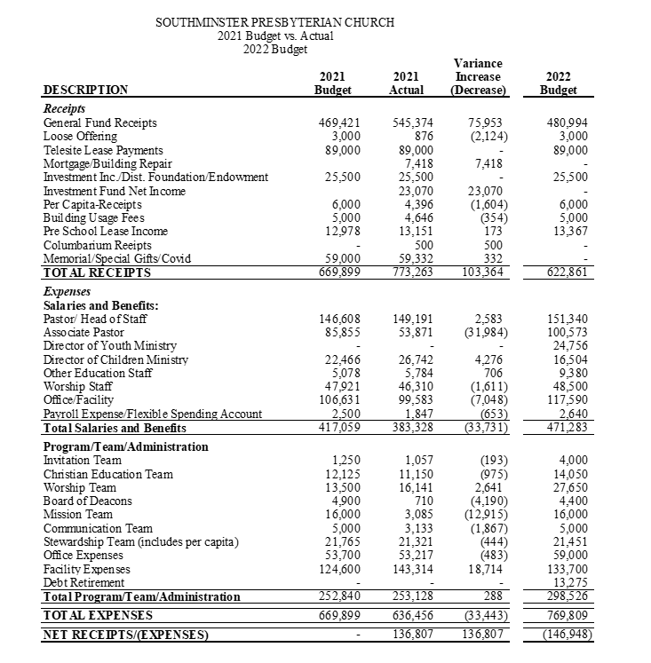

Finance Team
Southminster will close out 2021 in an excellent year-end financial position. Total receipts were 750,193. The income from our investments through the same period was $23,070. Total expenses were $636,456. You may recall we began 2021 with a balanced budget. And, tho’ the virulent tides washed the Earth in ways perhaps more violent than 2020, God Almighty blessed our humble congregation with a surplus once again. Similar to 2020, unpledged giving in 2021 amounted to $161,152 – far in excess of the budgeted amount of $85,775 set by Session at the start of 2021.
During the course of the year, we routinely transferred money from our money market funds in order to meet our obligations. This sort of movement is normal, as we no longer receive monthly income from the cell tower. Now we receive a single annual payment of $89,000, all of which was moved to our investment accounts until it is needed in the general fund. 25% of the $89,000 is being permanently invested in our Southminster Foundation in order to provide a nest egg for when the cell tower no longer provides any income (in 2038).
Finance asks the congregation to consider that we are working to increase our investment account balances in order to guarantee annual income of at least $89,000 after the cell tower income ceases in 2038. This means we must increase our investment funds to more than $2,000,000 from where we are today (just under $1M).
We received no estate gifts in 2021.
The Finance team thanks the congregation for their generous and timely financial support. We ask also that you remember the church in your estate planning.
Please remember that pledging for the year helps us to establish and maintain a budget for the church. If you are able to make a commitment, we would like to encourage you to do so each year. Also remember that for 2022 our per capita - which is the church's tithe to the Presbytery - is $52.23 per member.
Finance oversees almost $1million in investments, including both restricted funds (endowments) and general long-term savings vehicles. In 2021, our investment value increased by $122,266, after the transfer of $25,500 as budgeted to our general checking, from 877,724 in 2020 to $999,990 in 2021. This increase was due to market conditions which were favorable to our investment strategy throughout the year.
The Finance team meets every third Sunday of the month at 11:45 a.m. Contact anyone on staff or the team chair, Ryan Battelle (finance@sminster.com), if you have any questions.
Team Members: Ryan Battelle, Chair; Larry Schlotterbeck (assistant treasurer), Bob Murphy (investments), Patty Izor (treasurer), Ron Kuker, Mike Farmer, and Cyndi Platt.

Treasurer’s Report
Annual Financial Results

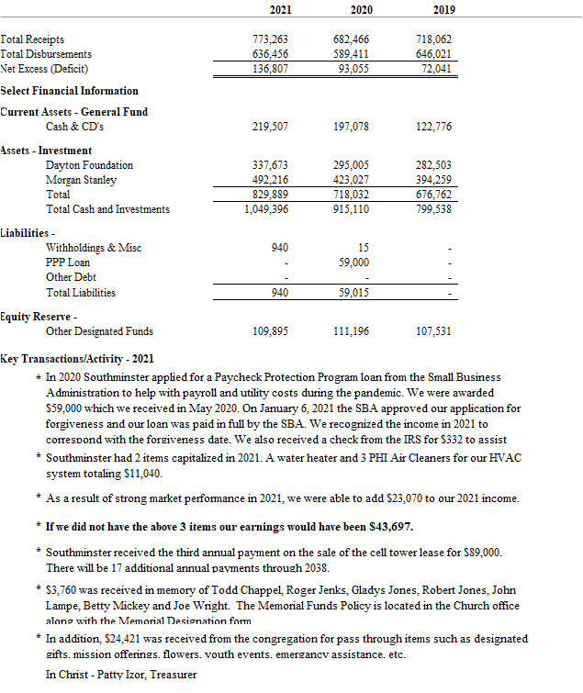

Stewardship Team

The Stewardship Team worked in conjunction with the Invitation Team to print, stamp and mail the pledge cards, letter, and the Time and Talent surveys, to every member of the congregation. As of
December 23, 2021, 93 households have pledged $400,574. The Stewardship Team hopes that members will prayerfully consider pledging for 2022.

Members: Kathy Jester (chair), Janice Young, Art Nitsch, Robert Clements and Nancy Birdsong, (ex-officio.)

Christian Education Team
The Christian Education Team has been busy this year as 2021 has been a roller coaster of a year, to say the least! We started the year strong with the continued Bible Study & Social Justice book group. The Lenten adult classes went well, and the youth group worked to get ready for Montreat. We adapted to the Covid related restrictions, trying to offer as many options as possible for church members.
Steve Davis’ Bible study continued to meet & added recordings for others to view if they could not attend. The youth group met virtually as well as (safely) in person, though attendance has been spotty.
Through summer & fall, we continued to promote virtual small study & social meeting groups. VBS was an outside endeavor that attracted many children, amidst the cicadas. The youth attended Montreat, and we learned of Laura Nile Tuell’s departure. The LRC continued to grow, as Gay purchases books related to social justice.
We ended the year with Advent small groups that met weekly, working through the book . We continue to brainstorm ways to increase interest in children/youth and adult learning groups.
Members include Karen Locke(chair), Gay Amos, Steve Davis, Jeanne Leatherbury, Herb Swiger, Josh Sweeney.
Children and Youth
In the Spring:
The youth continued to gather on Sunday nights and had a time of fellowship together. They put together a virtual talent show to raise money for the Montreat Youth Conference. The children’s ministry continued Power 45, ministry for 4th and 5th graders for a time of games, devotion, and service.
For Lent, the staff created An Interactive Ash Wednesday Service for Families that was uploaded to YouTube. The worship service brought together music, crafts, and other mediums for families to being their Lenten journey. The children participated in a burying and raising alleluias event. This event was in-person and through a take home kit. Families were given clay pots and seed paper for them to grow new life as Easter comes. The youth participated in the Stations of the Cross and Labyrinth that was provided through a Sanctified Art’s Lenten curriculum entitled, “Again and Again.”

In the Summer:
Rev. Laura Nile Tuell announced her resignation from Southminster and left a vacancy over the Youth Ministry. In July, Josh Sweeney took on additional responsibility of the youth and became the Director of Children and Youth Ministries.
For Children’s Ministry, VBS was deemed a success by all parties. Over 60 children and 25 volunteers created a unique week battling the cicadas and COVID-19 protocols. The theme was “God’s Big World and Me.”
For Youth Ministry, 5 students and 2 adults went to Montreat Youth Conference. Some of the students described their time as:
“Montreat feels like my home away from home. Every time I’m here I feel really connected to God through the people there”
“The best experience I have had with youth group ever…. the people we met there and the memories we made will last a lifetime”
“The energy throughout the people and the overall environment are like no other. I’ve made the strongest connections there.”
“Breathtaking, from the people, to the messages, from the views. Everything feels connected and warm, whenever I think back to it the memories are almost tangible”
In the Fall:
Blessing of the Backpacks kicked off our fall programming. The event was attended by Southminster members and the majority being children from the preschool to have their backpacks prayed over. Each child was given a cross to go on their backpack. Teachers and administers were also prayed over and given a frog as a reminder to Fully Rely On God.
The youth continued to meet on Sunday nights for fellowship and added service opportunities such as Church Has Left The Building and making lunch at the Ronald McDonald House. Also, Confirmation began with 2 students and will conclude in the spring.
Within children’s ministry, Godly Play and Sunday School for older elementary students resumed. The puppet ministry (PB’nJ) came back in the fall! Mark and Liz Ferguson had 8 students who rehearsed every Sunday from 5:15-6:00 p.m. for the Christmas Eve service for Children. Other events/worship services that were well received were Trunk or Treat, Breakfast with Santa, and Virtual Christmas Eve Service for Children.
Josh Sweeney

Nominating Team
The Nominating Team began meeting in February after receiving preparatory information and instructions in January. Our task was to present six Elders and 5 Deacon candidates to Session and the Congregation for approval for the Class of 2024 and to replace one Deacon for the Class of 2022.
We accumulated candidate suggestions from each team member for each position. Each member of the Team then took responsibility for making calls for a specific Team opening. We met every two weeks by Zoom to update each other on our progress. We were able to complete our task with total success by August. Unfortunately, two candidates later declined, but we were able to find replacements before the end of this year.
We were also tasked with forming an Interim Associate Pastor Nominating Team, and the Seed Gathering Committee to work with Pastor Nancy. Both of those tasks were accomplished.
My thanks go to the 2021 Nominating Team of Cindy Battelle, Suzi Dameron, Richard Jester, Mark Locke, Judy Murphy (Deacon Rep), Mary Stahley (scribe), and Phyllis Strayer.
Submitted by Gretchen Cleaves, Chair.
Worship Team
The Worship Team faced a lot of challenges this year. Our 1st challenge, since the year started with live-stream only services, was providing decoration and presentation that would have impact through the camera lens to the live-stream audience.
We were pleased to help Pastor Nancy in creating a Service of Lamentation and Remembrance in March to mark the 1 year, anniversary of the shutdown due to COVID.
Then came the challenge of creating and maintaining a safe environment when in-person services resumed in May. Following the guidelines of Southminster’s Safety Team, we worked on ways to maintain social distancing, and developed new protocols for Ushers & Greeters, as well as a safe way to serve Communion and receive the weekly offering. Our Music Director, Ruth Whatley made many decisions as well, to provide beautiful, meaningful music for Worship, while keeping everyone as safe as possible. This included the installing of a Plexiglass barrier; using a small ensemble of singers which could be spaced out in the choir loft and requiring them all to wear masks during each service.
For the special services during the year, we planned a pared down version of Heritage Sunday, with 1 bagpiper and short presentations by members of our Congregation from different ethnic backgrounds, explaining the way Worship is conducted in their cultures. Pentecost Sunday was a delight to plan, with balloons in fire colors, flowing sheer streamers and 2 Liturgical dancers who beautifully represented the movement of the Holy Spirit. Ruth & Pastor Nancy planned a Hymn Sing Service in September which was well received. A video presentation of people whom we had lost was put together for All Saints Day. World Communion Sunday was full of music from different cultures and included extra musicians.
One of the biggest challenges our Team worked through was the effect on our budget for 2021. There were various factors that had not been anticipated. With Pastor Laura’s departure, came the need for once monthly Pulpit Supply Pastors. When the choir was invited back, not all previous members returned, which required the addition of extra paid section leaders to fill in. The live-stream service required the need for various licensing agreements and broadcast fees, all of which had not been budgeted for. There was a big need discovered when examining the Christmas decorations. Most of what we had was years old and looking the worse for wear. New replacement items needed to be purchased as a result.
A big Thank You goes out to the members of the Worship Team for all the work and dedication to the projects and plans over the year.
Team Members: Elizabeth Davis, Janet Hall, Todd Hall, Cindy Stevens, Ginny Suarez, & Holly Woods. Pat Bethel started the year with us but had to withdraw for health reasons.
Submitted by Lois Thorp, Team Chair
Mission Team
Active Committee Members
Peter Garland (Chair, Session Representative, Committee member since 2018)
Nancy Birdsong (Staff Representative)
Jill Matteson (Session Representative, Committee member since 2020)
Joan Johnson (Session Representative, Committee member since 2021)
Kevin Dickson (Committee member since 2017)
2021 Mission Committee Focus: To maintain the outreach focus of our congregation during the
difficulties of COVID pandemic.
Ongoing Projects:
- FISH Southeast Food Pantry
  - The food pantry is our committee’s most active and long-lasting program.
  - We keep a pantry on the church campus and discretely deliver food to those in need within a five-mile radius.
  - During peek need periods, our pantry has assisted 28 households
  - We keep a Blessing-Box on the church grounds that makes quality food available on a 24/7, no-questions-asked basis.
- Church Has Left The Building (CHLTB)
This is one of our congregation’s major outreach efforts. It supports our Matthew 25 goals by replacing church attendance on a Sunday in October with multiple acts of mission support out in the community.
  - Made both lunch and dinner for the residents at Ronald McDonald House: a place that provides community, comfort, and hope for families of seriously ill children.
  - Performed yardwork at The Castle, a gathering place of trust and friendship for people with mental health concerns.
  - Supported the Dayton Strong outreach by clearing three years of yard overgrowth for a family seriously impacted by the Memorial Day tornados.
  - Prepared and donated 53 casseroles to St. Vincent De Paul’s Homeless Shelter.
  - Assembled more than 100 mailings for Hannah’s Treasure Chest; a non-profit for families that don’t have adequate resources for their children’s needs.
  - Sewed 52 school kit bags for this Advent’s Presbyterian Disaster Assistance project.
  - Assembled 18 blankets for Hospice patients
  - Assembled 10 large Clean-up Supply Buckets to be used for Disaster Assistance in areas that have been flooded this year. Pete’s neighbor may be able to deliver these Clean-up Supply Buckets.
- The Castle
  - Volunteers from our congregation support The Castle with their time as general volunteers, the donation of items and funds, and targeted assistance by talented members of the congregation.
- Clothes That Work
  - Our congregation supports Cloths That Work with clothing donations and volunteer assistance.
- Support Habitat for Humanity building efforts in the Dayton area.
  - This is a non-profit organization that empowers families in need to obtain their own homes. Our congregation supports Habitat for Humanity by cooperating with other churches in the region under an organization called Catch the Building Spirit. Sadly, COVID seriously limited home building efforts in 2021 and our contribution this year was a cash donation to build up supplies, resources and equipment in preparation for a time when we can gather to build more homes.
Developing Projects
- Helping Hands Mission
  - This is a new effort to engage locally by using the talents within our congregation and matching them to needs within our community. We expect to roll out this program in the Spring of 2022.
Membership:
- Many on the team have or are approaching the six years of service and are following the Session’s shift of focus guidelines. The Mission Team is always looking for new members and new ways of reaching out even if it’s a one-time event. You can contact us by speaking to any of the members, reaching out by FaceBook, emailing us a question, or dropping in on one of the monthly Zoom meetings; they are on the second Tuesday of each month at 7:00PM. Our email is: mission@sminster.com

Pete Garland, Chair
Note: For brevity, the Missions Committee is abbreviated in these minutes as “MC”

Marketing & Communications
The MarCom team served the church from several different perspectives:
- Marketing Outside
  - Worked with staff to continue posting and updating of information via Facebook, Instagram, Snapchat and sminster.com
- Communications Inside
  - Supporting the technology upgrade of Microsoft Office 365 for Church Staff
  - Introduction of MS Teams during September 2021 Session Retreat.
  - Introduction of new common calendar with signup capability in September 2021.
  - Updating lists for Constant Contact communications
- Streaming of Worship Services via YouTube
  - The following team members have been faithfully supporting Southminster by supporting the livestream of worship services since the start of the COVID-19 pandemic (21 March 2020):
    - Ralph Adkins, Ken & Darlene Irwin, Linda Wiggers, Cindy and Ryan Battelle, Mark and Ben Locke, Josh Sweeney, Todd Hall
  - There have been no major new financial investments made in streaming infrastructure during 2021, but the team’s ability to make use of the production software has greatly increased, which has made the worship experience for viewers more complete and engaging.
  - The Digital Friendship Pad was introduced early in 2021. The goal was to enhance connections with those viewing the worship service via YouTube. This feature enables those viewing the stream to register as participating and submit prayer requests. We estimate that approximately half of all stream viewers use the digital friendship pad.
Other Items:
- Shailendra Dwyer joined the team as a new Session member in January 2021.
- In August, Josh Sweeney accepted the position of Youth Ministries (in addition to his previous role of Director of Children’s Ministries).
- MarCom worked with Personnel to create a job description, solicit candidates, and conduct interviews for a Communication Coordinator staff job. We are pleased to announce that Katie Rice was offered and accepted the position starting December 1, 2021.
Looking ahead into 2022, we are hoping to have traction on the following items:
- More dynamic use of Southminster’s digital sign along Far Hills Avenue.
- Better understanding of our marketing capabilities, using common metrics from Google Analytics, Facebook, and Instagram.

MarCom is proud to serve the church and the congregation, and we look forward to providing exceptional service in 2022 in support of the growth and prosperity of Southminster to the glory of God Almighty.
Todd Hall

Invitation Team
In the early fall of 2021, with the decline of Covid, our church had the opportunity to return to “in-person” worship” and continued our worship experience with our “virtual” attendees. By the end of the year, our church attendance records indicated that each venue appeared to have a dedicated and continual attendance. This new reality of the 2 venues should inspire a new focus toward our Team’s mission: to “lead the congregation as we invite people into relationship with Christ; warmly welcome them to Southminster; introduce them to all Southminster has to offer; and bring them into membership (if they desire)”.
Some of the renewed efforts of our Team included:
- A warm welcome from our Greeters and Welcome Desk at our renewed “in-person” worship experience.

- Taking our message to our church website: After sharing thoughts, our Team posed 2 questions: “who is the audience” and “what is the purpose” for our website; we propose that our website has a dual role:
  - to invite non-members to engage with us, and
  - to provide members with information and support.
Josh suggested that our Team identify “talking points” and provide pictures of our mission in action which we should continue in future years.
- Outreach to guests who attended Sunday services and church activities: our team members continued to make contacts to guests who visited us in person and virtually. We also became more involved with our support for the “Back Pack” and “Breakfast with Santa” activities.
- Outreach to church members to continue involvement in the life of our church: our Team updated our annual “Time & Talent” booklet and “Volunteer Pledge” form for 2022; it was mailed with the Stewardship Pledge forms in November. An early submission of volunteer contacts was provided to the Invitation Team and MarCom Team to enable preparation for Greeters and Ushers prior to the new year.
- Outreach to our community: We began the process of planning for our 2022 presence at Americana Festival.

As in years past, we have been blessed with the guidance and experience from our veteran Team members and support members: Adrienne Dickson, Marj Lawson, Jean Gaffney, Cheryl Hartman, Mark Ferguson, Kate Scarpero, and new member, Brenda Ricketts.
In 2022, we look forward to continuing more of our outreach activity involvement with our community; also, to provide more awareness for active involvement and membership for our “virtual” members and guests.
Tom Novak – Invitation Team Chair

Buildings and Grounds Team
Southminster Buildings and Grounds Team worked in 2021 to maintain our facility with routine maintenance and repair and these projects:
- Southminster hired a new Building Tech, Jimmy Hoshue. He has done a very good job clearing minor repair items off the check list. The B&G Team is very excited to have Jimmy back on staff.
- The heating system required several repairs using a significant portion of our maintenance budget. Repairs were made by Rieck. Inquiries were made to Rieck on the best options to maintain or replace the heating plant. After evaluation it was determined following a rigorous maintenance schedule is the best option. We contracted with Solid Blend Tech to install water filters for the boiler system and treat the water twice yearly. This should extend the service life of the boilers.
- The CFC and Kitchen AC systems failed mid-summer. In addition, the sanctuary and office systems are past their service life. We obtained estimates from two contractors and several “no-bids” meaning they could not provide the work requested. After much discussion it was decided to contract with Rieck to replace all four AC systems. This will offer significant savings over replacing each system individually as well as reduce overall maintenance costs.
- Motor in the Sanctuary video screen was replaced.
- Retention ponds were clogged and flooded. They were cleared.
- Outside electric sign had defective panel that was replaced.
- Steps repaired outside doors 12 and 13.
- The new CFC carpet was cleaned to meet warranty requirements, and had seams repaired.
- The south side landscaping was cleared of old bushes around the AC compressor to improve efficiency and access. Area will be prepared for a new landscaping plan.
- Painted pavilion with the help of Scouts. Scouts also painted the picnic tables.
- Worked with Essential Lawn and Irrigation and volunteers to maintain our gardens and lawn areas. Scouts did spring cleaning of leaves outside around the church.
- Continue to meet via zoom amid Covid protocols that were put in place

Fellowship
Fellowship was shut down for most of the year. We did participate in honoring Pastor Laura with a farewell celebration in June out at the pavilion. In August we supported the Blessing of the Backpacks in the pavilion with a luncheon after services.
Elderberries gathered in September at the pavilion for a hymn sing-a-long, led by Gay Amos and Art Nitsch. Everyone brought their own lunch, and drinks were provided. Elderberries decided to keep the “bring your own lunch” format due to the current Covid situation. In October we met inside the CFC and had a representative from the Medicare Connection who spoke to us about changes in Medicare and provided information on scams targeting seniors. This event fit in well with the upcoming open enrollment. In November, it was exciting to have Ralph Young share stories from his book “Forgotten Warriors and the Pacific battles of WWII.” December was a Christmas sing-a-long with the preschoolers from A Great Start preschool who entertained our seniors.
Personnel Team
2021 was a year of transition and change in the staff of Southminster and the Personnel team. The end of the first quarter we transitioned chairs of the personnel team and our Property Technician, Christian Zennie resigned. Thru the extra efforts of the Building & Grounds team under the leadership of John Woods, and the support of Sharon Ark and Wes Cleaves they were able to maintain the facility and keep things running smoothly until we had the great fortune of being able to rehire Jimmy HoShue.
In May, with the church reopening, we hired an additional childcare worker, Caroline Adkins, to help provide a safe and cheerful atmosphere for our youngest visitors.
Our next transition was the resignation of our Associate Pastor, Laura Nile-Tuell. We began preparing for the transition in June working on reassigning the critical job responsibilities of the Associate Pastor position. With our primary focus on our children and youth, we were excited that Josh Sweeney was willing to step into a modified role as the Director of Children’s and Youth Ministries (30 hours) and Social Media Coordinator (5 hours). We are so grateful that his passions and skills align so well with our needs and that our children and youth will benefit from that energy.
Personnel Team also worked closely with Nancy Birdsong, Pastor Head of Staff, to develop an Interim Pastor Responsibilities list to review with the Presbytery and give to the Interim Associate Pastor Search Committee. And finally, we rounded out the year, working with the MarCom Team, to hire our part-time Marketing and Communications Coordinator, Katie Rice. We are excited to have a person fully dedicated to enhancing our presence on social media, and providing a clear and consistent message of who we are as a church and a congregation.
I wish to personally thank all the members of the Personnel Team for their efforts this year and a special thanks to Ron Kuker and Dick Stevens for their past years of service to the Personnel Team as they rotated off the team the end of December.
Additional thanks to Pastor Nancy and the wonderful staff of Southminster for their teamwork and efforts through a year of change.
Liz Ferguson, Chair of Personnel

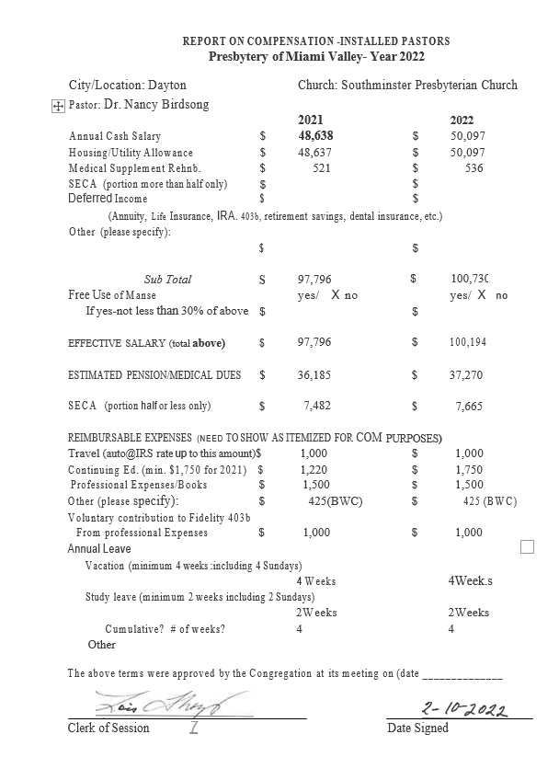

Prayer and Presence
Our team did the best we could during another difficult year with COVID. Below are the totals of our separate ministries:
Hello-Good Morning…This ministry pairs individuals who live alone; they are asked to call each other daily to be certain their partner is okay and in no need of assistance. Deanna Brewer reports there are 16 people involved at the present time.
Care Connection…This ministry extends the love, care and hospitality of Christ to those connected with Southminster through regular phone calls. Special prayer requests or needs are recorded, and prayer requests are then confidentially relayed to the Intercessory Prayer group and the Pastors.
Care Connection is still going strong & calls are now being made from home for the safety of our callers. It is working well. Marion Kaufman and Suzi Dameron are coordinators of this ministry, and they report the following numbers:
Number of calls made for 2021: 1311 Connections: 558; Prayer Requests: 322; Postcards Sent: 17.
Homebound Visitation… This ministry coordinates visitation opportunities to those connected with Southminster who are homebound or reside in care facilities. The visits, and in some cases phone calls, are typically made monthly. No visitation was possible this year due to COVID restrictions.
Home Communion…This ministry provides monthly communion to people who are not able to attend regular worship services. A two-member team of communion servers (an Ordained Deacon or Session person) takes and shares the Sacrament of Communion with homebound or nursing home members. Again, COVID restrictions prevented this to continue this year, but we are praying it will begin during the 2022 year!
Hospital & Rehab Visitation…This ministry offers spiritual support and encouragement through weekly visits, to those who are currently hospitalized or are in Rehabilitation. Marilyn Kemper works with Pastor Nancy, and again, no visits were allowed this year. Hopefully in 2022 it will be possible to continue this ministry.
Follow-up calls…This ministry offers spiritual support and encouragement to individuals recently discharged from the hospital or rehab services; and also, for those who face life challenges or have lost a loved one.
Email Prayer Chain…This ministry relays special prayer requests to members who pray for each request. Prayer chains exist via email and phone calls. Judy Murphy organizes this ministry and there are 105 prayer partners involved. This year 265 prayer requests were issued to those participating.
Care Notes…This ministry offers care and support to children, teens and adults through professionally written small pamphlets called Care Notes and are available on a wide variety of topics and provided free of charge. They are distributed in various areas of the Church building. Barb Adams has checked the racks throughout the year and replenishing them when needed.
Respectfully submitted,
Judy Murphy, Chairman
2022 CHURCH OFFICERS
SESSION
CLASS of 2022
Gretchen Cleaves Nominating*
Jean Gaffney Invitation
Pete Garland Mission
Todd Hall Marketing and Communications*
Kathy Jester Stewardship*
Karen Locke Christian Education*
Liz Ferguson Personnel*
CLASS of 2023
Shailendra Dwyer Marcom
Jill Matteson Mission
Andrew McKenzie Buildings and Grounds
Cyndi Platt Finance
Ginny Suarez Worship
Marie Sutton Personnel
CLASS of 2023
Gay Amos Invitation
John Breed Finance
Mary Baez Christian Education
Joan Johnson Mission
Lois Thorp Worship*
John Woods Buildings and Grounds
Ryan Battelle Finance*
(Not currently serving as an Elder)
Team Chair*
BOARD OF DEACONS
Moderator
CLASS OF 2022
Kim Catchpole-Patton Prayer and Presence
Steve Davis Prayer & Presence
Mel Kelley Fellowship
Shirley Oglesbee Compassion & Assistance
Britt Platt Prayer & Presence
Linda Wiggers Prayer and Presence*
Art Nitsch Fellowship*
Lisa Rawls Prayer & Presence
Sandy Stevens Fellowship
CLASS OF 2024
Sherri Swiger Moderator
Joanne Yost Compassion and Assistance*
CLASS of 2023
Bill Barlow Fellowship
Darlene Irwin Fellowship
Marilyn Kemper Prayer & Presence
Gretchen Locke Compassion and Assistance

