Annual Report
2016

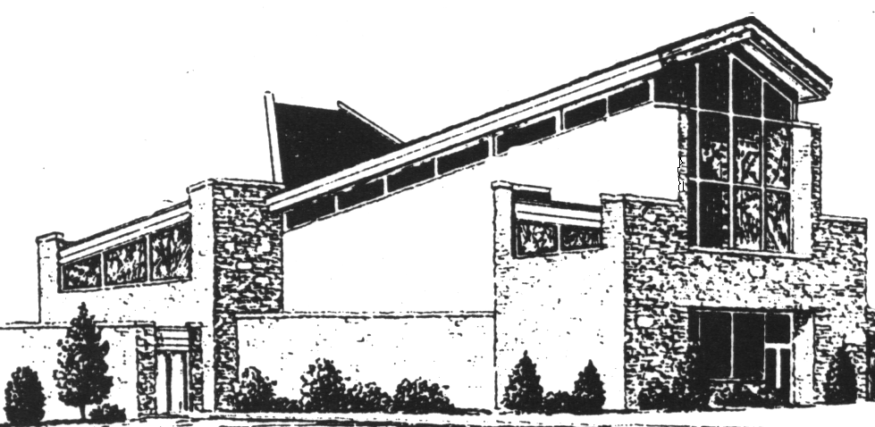

“Lighting the Pathway to God;
Touching Lives for Christ”
Sunday, May 6, 2007 8:30 & 11:00 a.m.

7001 Far Hills Avenue, Dayton, Ohio 45459
937-433-1810 (phone) 937-433-7665 (fax)
www.sminster.com
“Lighting the Pathway to God;
Touching Lives for Christ”
Sunday, May 6, 2007 8:30 & 11:00 a.m.

7001 Far Hills Avenue, Dayton, Ohio 45459
937-433-1810 (phone) 937-433-7665 (fax)
www.sminster.com
“Lighting the Pathway to God;
Touching Lives for Christ”
Sunday, May 6, 2007 8:30 & 11:00 a.m.

7001 Far Hills Avenue, Dayton, Ohio 45459
937-433-1810 (phone) 937-433-7665 (fax)
www.sminster.com
“Lighting the Pathway to God;
Touching Lives for Christ”
Sunday, May 6, 2007 8:30 & 11:00 a.m.

7001 Far Hills Avenue, Dayton, Ohio 45459
937-433-1810 (phone) 937-433-7665 (fax)
www.sminster.com

7001 Far Hills Avenue
Dayton, OH 45459
937-433-1810
www.sminster.com

Steve Plunkett
Interim Pastor/Head of Staff

By my estimation, 2016 was an excellent year in the life of Southminster Presbyterian Church. When I arrived here in November of 2015, I was well aware of the turmoil and trouble that you had been through during the preceding year and a half, and I knew that one of my tasks was to approach my job in a way that healing could begin to happen. I am grateful to God for the gifts of grace that I have seen at work in and among you. Healing has taken place, relationships have mended, and from all I can see, Southminster is a stable, happy faith community at the present time. I am thankful that God has been at work in our midst with reconciling love, but I am also thankful to you who have reached out to one another with kindness and love.

We have been in a time of transition, not only pastoral transition, but also in terms of relationships within the congregation. I am delighted to say that I sense a real change in the character of this church family and that you are doing an excellent job of paving the way for a new installed pastor.

One of the main things that happened in 2016 was the election of the Pastor Nominating Committee (a.k.a. PNC). After the series on Envisioning God’s Future for Southminster, I worked with a dedicated group of people who put together a statement of where we are as a congregation as we look toward the future. This statement was honest about where we have been, but it wasn’t stuck in the past, being forward-looking as well. That was approved by the Committee on Ministry of the Presbytery with a strong affirmation of the progress we have made, and permission was granted to elect a PNC. You might be interested to know that the Committee on Ministry said that we moved to the point of electing a PNC in record time. They said that the Interim Pastor is usually present for an entire year before that happens, but their approval came on July 26 and the PNC was elected on August 14, well before my first-year anniversary date in November.

We were given the gift of new members in 2016, as well as increased financial giving. Going forward into 2017, we have much for which to be thankful, and I know that you join me in gratitude to God for the grace that is abounding in our midst.

Margaret and I feel blessed to be here. We have come to love this congregation very much, and know that it will be a sad day when the time comes to say good-bye. You have embraced us with your love, and we thank you from the bottom of our hearts.

Please join me in prayer for the PNC as they go about the important work of finding a new installed pastor for Southminster. They are a wonderful group of people, totally dedicated to their task, and I could not be happier about the make-up of the committee as well as the excellent way in which they work together.

As we enter 2017, I feel like praising God with shouts of joy, and I am reminded of Psalm 103, which encourages us to “Bless the Lord, O my soul, and all that is within me, bless God’s holy name.”

With love from you friend and pastor,

Associate Pastor
The Rev. Dr. Jacqueline Nowak

Visitation, prayer, nurture, worship, education, fellowship and mission – these categories encompass my work at Southminster in 2016. As Pastor primarily responsible for oversight of the care of members, I, along with many others, ministered to the people of this Body of Christ. Home Communion, Hospital and Rehab Prayers and Visitation, Stephen Ministry, Prayer Chains and Intercessory Prayer Group, Funerals and Memorial Services make person-to-person connections. Tangible Items of Blessing, such as Lambs, Prayer Shawls, Baby Prayer Blankets and Booklets, Blessing Oil and Grief Books are offered to provide a sense of God’s presence and a reminder of the care of the community. I am Staff Resource to Deacons, its Teams and individual ministries, A Great Start Preschool, Mission Team, Christian Education Team, with a focus on Adult Education and offer support and supervision for Erin Dickerson. In addition to meetings, and all of the above, I participate in weekly worship, plan special worship services, officiate with Pastor Steve at the Sacraments, and also with Steve, provide New Member and Officer Training.
Pictures are worth a thousand words, it is said: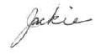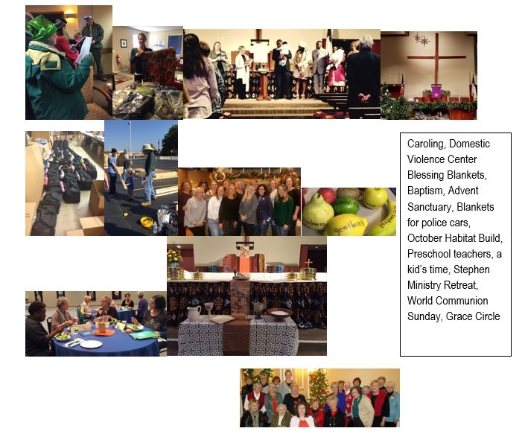
- INVITING TO WORSHIP
  - Invitation Committee (Evangelism and Membership Team)

The Invitation Committee has been renamed the Evangelism and Membership Team. The newly named team was only able to meet one time after the chairperson transitioned in spring. The primary focus of the team at that time was to recruit additional greeters and create a visitor’s pamphlet. Greeter scheduling for 2017 was organized in the winter, with additional greeters posted upstairs and downstairs. The new team’s work will continue in 2017 with a new chairperson.

Submitted by Andrea Calim

  - Worship Committee

The Worship Team’s primary focus is providing support to Worship Services. We schedule ushers, liturgists, computer support and sound system. These programs rely on the members of our church willing to offer their time and talents. Our volunteers are busy behind the scenes with Communion setup, flowers for Easter, Memorial Day and Christmas. This years at Thanksgiving we hosted a food drive to support the food pantry. In this one service, we collected over 270 assorted items for the pantry. Jane Barlow coordinated the décor for our Christmas décor and the Hanging of the Greens in December.

Submitted by Marie Sutton, Worship Chair

- LEARNING IN COMMUNITY (Christian Education Team)
  - Learning Committee (Christian Education)

The Southminster Learning Resource Center/SLRC has benefited from a modest increase in circulation by our church members who are enjoying the fiction section, and by the Christian Educator group - moderated by Erin Dickerson - which meets bi-monthly at Southminster, giving them a chance to peruse the collection and borrow new materials.

We have improved our commentary section on Old Testament books by completing the wonderful Interpretation series, and recently added books dealing with contemporary issues in the United States. Now we would like to concentrate on increasing curriculum studies in our DVD section.

Submitted by Gay Amos, Librarian

    - Children’s Education

2016 began with my attendance at the Association of Presbyterian Christian Educators (APCE) National Conference in Chicago. The leaders and organizers of APCE did a wonderful job of presenting a variety of styles of preaching and worship throughout the conference.

Elizabeth Caldwell, author of the book “I Wonder”, presented the class “What’s New in Children’s Bibles and Bible Storybooks?”. As a new Director of Children’s Ministries, I learned valuable ways of looking at, comparing, and evaluating the Bibles, Story Bibles, and curriculum I choose to use. “Being on Staff During Times of Transition” helped put the process of transition, and the changing roles during the process, in perspective. Laureen and I also participated in Ministry Architects. Due to miscommunication and double booking, we were unable to get our diagnostic report until after APCE closed. We held a conference call a month later to review the results and discuss possible ways to improve, not only the Children’s Ministries, but also ways in which the Director of Youth Ministries and I could work together to strengthen our church and help it move forward.
A grant was applied for through the Presbytery to add additional resources and training for those involved with our Special Needs Ministry. Unfortunately, we were not granted the funds, but we continue to look for ways to expand our resources.
Our nursery worker, Jessica Swisher, heavy heartedly resigned her position in the nursery. While working to fill her position, we have been blessed with some wonderful help from BrightStar Staffing.
Thanks to a donation, additional storage units and light covers have been purchased for the nursery. We are very thankful for the generous gift!
Vacation Bible School was attended by over 55 children and had over 60 adult and youth volunteers. The week’s focus was on various disabilities, inclusion, and the need to love one another.
In the fall, we began GIRAFFE Nights, a monthly intergenerational activity night designed to bridge the gaps between the generations and provide fellowship and learning for all ages. GIRAFFE is an acronym that stands for God Inspired Relationships And Faith Formation for Everyone.

Other changes this fall included the children ages 4 - 3rd grade began using the Shine On curriculum during Sunday School; Children and Worship changed to being for children ages 4 - 2nd grade, and Sermon 2.0 was created for those 3rd grade and above.

This December, Personnel and Session approved a change in the job description for the position of Director of Children’s Ministries. The Director of Children’s Ministries is now responsible for children from birth through 3rd grade.

Submitted by Erin Dickerson, Director of Children’s Ministries

    - Growth Groups Subcommittee

The Growth Groups Subcommittee facilitated a number of educational opportunities for adults during the year, including:
- A study of the book This We Believe led by the author himself- our Interim Senior Pastor—Steve Plunket.
- A study of the Advent portions of Handel’s Messiah led by Richard Bobo
- “A Year Through the Bible” led by Pastor Steve
- Studies of the books of Exodus, Leviticus, Numbers, Joshua and Judges led by Steve Davis
- A class led by Pastor Steve focused on envisioning Southminster’s future mission and outreach
Members of the Subcommittee included Jeff Acred, Drew Fisher, Lois Thorp and Steve Davis (chair). Pastor Jackie Nowak was our staff resource.
Submitted by Steve Davis, Chair
    - Youth

Kim Catchpole
Interim Director of Youth Ministries

This year 2016 saw another transition in Youth Ministry leadership from Laureen Roe (January – September) to myself (October – December). Laureen focused on healing and growing the youth ministry program, shifting to a Christ-centered, mission-focused ministry. Average attendance for youth gatherings was between 2-5 people and it was determined that rebuilding the ministry will take 3-5 years. Since October, I have continued to build on the foundation Laureen put into place.

On April 24th, Laureen Roe and Erin Dickerson held a Visioning Round Table Discussion during which parents, children, and youth were able to share information that would help guide the ministries in the future. As a result of feedback shared during this session several developments took place. Core Youth Ministry programs, DOG House (Disciples of God meeting in God’s House) and PB&J (Proud Believers in Jesus) Puppets, were scheduled to take place on Sunday nights, making it more convenient for parents and youth. Families also indicated a need for more intergenerational opportunities, which resulted in the development of the GIRAFFE ministry (God Inspired Relationships and Faith Formation for Everyone). Parents also vocalized a need for youth ages 8-12 to have a worship component that was separate from and more developmentally appropriate than Children and Worship. This brought about the development of Sermon 2.0.

In the summer of 2016, youth had three opportunities for in-depth faith formation. Six youth participated in Youth Mission Week, providing service to Crayons to Classrooms, ARDR Rwanda Allies, the Marianist Environmental Education Center, A Great Start Preschool, and House of Bread. Six youth traveled to North Carolina to attend the Montreat Youth Conference. Eight youth traveled to Michigan to attend the Heifer International Global Village program as a culmination to their Sunday School Heifer International project.

Sunday Morning Christian Education included Confirmation Class using the Professing Our Faith Curriculum. Three youth attended regularly. Youth in grades 4-8 attend Journey to Exercising Faith. This class, led by Josh and Abby Locke, engaged the whole congregation in tracking their physical and spiritual activities.

With the transition to a new Interim Director of Youth Ministry, the position description grew to include 4th grade through 12th grade. I also took on the additional responsibilities of Date Night and GIRAFFE night. I began working in the position in October for 12 hours per week and shifted to 30 hours in January 2017. I am looking forward to seeing the Youth Ministries at Southminster continue to grow and thrive in the year to come.

  - Board of Deacons
    - Compassion and Assistance
      - Health and Wellness

The Compassion & Assistance Committee of Deacons oversees:

AED/CPR Training and Oversight
This ministry helps to ensure that attendees of events at Southminster can be responded to with proper emergency care in the event of certain unexpected health crises.

Anxiety/Depression Group
This ministry allows for a peer-led group of people to meet casually on a regular basis to discuss a variety of mental health issues, coping strategies, and treatments. No formal therapy or counseling is provided, but the purpose of the group is to be a sanctuary where people can come to see that they are not alone in their struggle and that real progress can be made in living with mental illness.

College Care Packages
This ministry provides packages to college students who are away from home to let them know their home congregation is thinking of them.

Flu Prevention Clinic
Provides an opportunity for anyone to receive an annual flu vaccine, done in coordination with a local pharmacy.

Gentle Yoga
This ministry is an instructor-led fitness class that provides healthy exercise and stretching techniques.

Grief Support Group
This ministry offers a monthly opportunity for people at Southminster, and friends, to gather to support one another after experiencing deep loss. The basis of this group is the book Tear Soup, and the group calls itself, The Soup Group.

Hometouch Letters
This ministry provides continued connection to people who are not able to attend Southminster physically by sending weekly letters to them. These letters share interesting details about life and ministry at Southminster and include Bible readings and a devotional message.

Needlecraft Group
The people involved with this ministry create hand-made items to distribute to those within and outside of Southminster who would benefit from such, as reminders that they are blessed and being prayed for.

Sanctuary Flower Delivery
This ministry provides encouragement of flowers to people connected with Southminster and makes good use of the flowers donated for Sunday morning worship.

Sanctuary Lambs
This ministry places plush toy lambs in the Sanctuary to be taken by anyone who needs one for love and support. The lambs are reminders that they are lambs cared for by the Good Shepherd, Jesus.

Share Your Garden
This ministry provides an opportunity for gardeners and plant-lovers to share the results of their efforts with others; with optional financial contributions benefiting Southminster’s food pantry. This may include sharing perennials or houseplants in the spring and produce in the summer.

Take Them a Meal Program
This ministry provides a coordinated method for people within Southminster to provide meals over a short period of time to another person within Southminster. This can be helpful during a recovery period after a hospital stay or other need that limits the ability to prepare meals.

Tangible Items of Prayer and Blessing
This ministry makes and distributes small blankets and shawls to those people needing something to remind them of God’s caring warmth for His people. The Needlecraft Group contributes to this ministry.

The Blessing Center
This ministry provides spiritual formation and pastoral care especially for children and teens, but also for adults. Trained leaders provide the necessary guidance.

    - Fellowship Team

The Deacon Fellowship Committee completed another successful year of service to the congregation. Supported events included: Maundy Thursday carry-in potluck, Heritage Sunday brunch, the congregational summer picnic, the Hanging of the Greens congregational potluck and the Deacon appreciation dinner.

We also received excellent support from the congregation for the Coffee Corner. Presby Groups, church social groups and individuals all stepped up to provide a wide variety of baked goods, both before and after the Sunday service, for nearly the complete calendar year. This was all made even easier by a single individual’s volunteer efforts to make and serve coffee during the year, as well as going forward.

Submitted by Richard Jester

    - Prayer & Presence Team

The ministry of Prayer & Presence reaches out to the congregation, supporting others through the gifts of listening, presence, prayer and lay counseling. The Committee consists of 4 Deacons (Peg Sperry, Peggy Stichter, Judy Murphy and Barbara Adams) and 2 members-at-large (Marion Kaufman and Carolyn Kennedy, The Prayer and Presence Committee consists of 8 ministries, (Care Connection Calling, Hello-Good Morning, Care Notes, Homebound visitation, Hospital and Rehab Visitation, Follow-Up Calling and Homebound Communion)

The Hello-Good Morning ministry connects individuals living alone. These individuals check on each other daily in a brief conversation. This ministry has one team with 14 members participating.

Care Connection ministry involves 5 teams (3-4 people per team) calling members of the Congregation on Sunday nights to learn of prayer concerns and joys to share. Each household is called 6 times per year Suzi Dameron & Marion Kaufman are the coordinators.

Irene Tipsword has coordinated the Care Notes ministry. These small booklets offering spiritual support and help on care needs are located in 3 areas of our Church. Members & visitors of SPC have made use of over 200 of these Care Notes, available at NO CHARGE to the congregation.

The Homebound, Hospital and Rehab Visitation ministries have many faithful volunteers connecting by phone or personal visitation with people dealing with health and aging issues. The Hospital and Rehab visitation ministry averaged 3 visits per month. Church members who have been recently hospitalized or are at home dealing with other life challenges are also called on a monthly basis. This is referred to as the Follow-Up ministry, with over 120 calls being made in 2016. Thanks to Judy Murphy for her leadership in this ministry.

The Prayer Chain continues to be an efficient telephone chain and an efficient E-mail Prayer Chain. Carolyn Kennedy coordinates this special ministry and over 200 prayer requests were received in 2016. The Intercessory Prayer Group continues to pray for specific requests and prayer concerns.

The Homebound Communion Ministry, coordinated by Peggy Stichter consists of past and present Deacon and Elder teams volunteering to take Communion to homebound or nursing facility members on or near the 1st Sunday of each month.

Submitted by Marianne Farmer, outgoing Chair

      - Stephen Ministry
Stephen Ministry is alive and well here at Southminster. We started the year with 10 active Stephen Ministers, 2 of which are also Leaders. During the course of the year many had Care Receivers. We currently have 3 ongoing caring relationships. Stephen Ministers find other ways to serve by volunteering for hospital visitation. We provide materials on grieving to those in our congregation who have lost loved ones. Additionally, we volunteer to help cover minor pastoral care needs when Pastor Jackie is away. In September we enrolled 2 students in the Presbyterian Network Stephen Ministry Training program. Also in September the Southminster Team hosted a weekend retreat for the launch of the current training class members and presenters. We served a catered dinner Friday night and a light brunch Saturday morning to between 14 and 17 people. We were sad to say goodbye to Barbara Lambright last spring when she & Joe moved to South Carolina. The end of the year marked the retirement of Pat Custer from active ministry, another sad loss to the team. However, we will be pleased to welcome Lana Ellinger and Al Herner to our team when they finish training and are commissioned this Spring.

- We helped cover Pastor Jackie’s vacations and study leaves by being on call for pastoral needs.
- Stephen Leaders interviewed potential Stephen Ministry candidates and are in the process of planning for training classes.

The Stephen Ministry Team: Leaders George Lawson, Lois Thorp; Stephen Ministers: April Bennett, Sharon Boyko, Pat Elliott, Marilyn Kemper, Peg Sperry, Sandy Stevens. Staff Liaison: Reverend Dr. Jacqueline Nowak

    - Welcoming Team

In 2016, the Welcoming Team assigned buddies to 13 new members to help them make friends and get assimilated into the congregation. We started working with the Membership and Evangelism Team to discuss how we could work together to identify potential members sooner and have buddies lined up for them by the time they "officially" join the Church, or even before.

The Welcoming Team reached out to the members and facilitators of the Small Fellowship Groups to see how things were going and encourage them to continue their events. There are some groups that had people signed up but did not have a facilitator. We tried advertising the groups in the spring through a "minute for mission" during a service, and with signs in the Narthex.

In the fall, we conducted another successful "Sharing Your Gifts In Ministry" signup with the congregation. In 2016, we provided the hard copies of the ministry booklets AND a digital copy that was on the Church website. We had a paper signup during one of the services in October, and we also had an online form that people could fill out. A link to that form was provided on the Church website on the same page as the ministry description booklet. We had a lot of responses of people volunteering to serve in various ministries throughout the Church. The first priority of the Welcoming Team in 2017 has been to make sure the appropriate people reach out to those who volunteered to serve in ministries.

Submitted by Brandon McFarland, Chair

- SERVING AS STEWARDS
  - Mission Team
Service to local missions as well as global outreach was evident in the giving of Southminster congregants in 2016.
Early in the year the committee decided to continue offering the monthly opportunities for giving: 1st Sundays: FISH-SE Food Pantry, 2nd Sundays: Loose change for the Southminster Emergency Fund, 3rd Sundays: Food4Tots, 4th Sundays: Food donations to The Castle, 5th Sundays: collection of items for the Dayton VA.
During the year the following mission programs were supported by Southminster:
* The collection of special offerings: One Great Hour of Sharing, Peace and Global Witness, Christmas Joy, and A Pentecost offering.
* Donations to Food4Tots: Priscilla Stapleton has been in charge of this local mission. It collects child-friendly, easy open, pre-packaged healthy foods to give to approximately 20 students.
* Over 50 church members (many of them multiple times) provided monthly meals to The Castle which is “a gathering place of trust and friendship for adults who experience mental disorders.”
* A continued collection of gently used books for the House of Bread; also monetary donations were given.
* Monthly donations of change given to Southminster Emergency Fund. The Mission Team wrote up a policy that was approved by the session.
* The FISH Southeast Food Pantry continued its mission of serving people in the Washington Township, Centerville, and Kettering communities. Jane Kessler serves as Pantry Coordinator, David Kaufman as Stocking Coordinator, and Alan and Robbie Herner track data entry and make weekly food purchases. We have served 547 people, for a total of 8,205 meals. We try to provide 15 meals/person or 5 days of food each time we deliver. As for our balance sheet, we have received $1,578.26 and have spent $4,279.60. In the past, Fairmont Presbyterian Church has provided about 50% of our income. At this point, they are still evaluating their financial support to the Food Pantry. We have 5 people who volunteer as "callers"; 3 who attend Southminster & 2 from other churches. We have 10 people currently as "deliverers"; 2 attend Fairmont, 7 attend Southminster & 1 attends somewhere else. We can always use more callers, deliverers, and money. We also had our annual audit by the Foodbank & passed without any problems.
* 5th Sundays and Christmas collection of items for the VA: 92 boxes were filed and delivered to the VA at Christmas time. This mission continues to be very successful. Thanks go to Brenda and Joe Ricketts for chairing this ministry.
* Provided snack bags with a water bottle and information for people from the community who come into the church office and might need assistance.
* Collecting of pop tops to give to Ronald McDonald House
* Ongoing clothing/accessories collection for Clothes That Work. This organization provides appropriate clothing for job applicants/interviewees
*The mission team provided a sponsorship of $250.00 for a benefit concert to help raise funds for Brigid’s Path.
*The Mission Team applied for a grant and received the funds from the Northminster Mission Fund for $5,000. $3,000 came from the Ireland Mission Fund. On October 15th over 100 congregants and community members, built a home on our parking lot. The mission team organized the build thru Cross- roads and donated it to Habitat for Humanity. This was a great success and the Mission Team is now planning the spring build.
*In 2015, Southminster received an annual $3,000 grant from the Ireland Mission Fund through the Dayton Foundation. The monies can accumulate over a 3-year period, and it is hoped that the grant will be used in 2016 or 2017 for Southminster to host an onsite Crossroads/Habitat for Humanity Build.
The volunteers who serve in these numerous missions are many and we thank them for their dedication and faithfulness.
Submitted by Laura Torres, Chair

  - Stewardship Committee
    - Building and Grounds Subcommittee

Southminster Building and Grounds Team worked in 2016 to maintain the beautiful facility with routine maintenance and repairs and these projects:

- Contracted with Anago to clean our facility
- Updated the Emergency Response Plan booklets which are in each room
- Filled the roll of Funeral/Memorial Coordinator with a volunteer and updated the job description with Pastor Jackie
- Oversaw the installation of a new Bryan Flex Tube Boiler for the CFC wing. We used the $5000 rebate from DPL from the installation of last year’s education wing boiler to offset some of the cost
- Installed contrasting colored tape on Sanctuary steps to improve their visibility
- Arranged ALICE (armed intruder) training for church leaders
- Completed a partial fix of major parking lot cracks as budget allowed
- Completed plumbing repairs above the choir room and in women’s Sanctuary restroom
- Worked on parking lot safety issues with the Pre-School
- Worked to improve and maintain security for staff, members and facility
- Caulked around windows to stop and prevent water leaks
- Reviewed the Pre-School lease to ensure rent was covering the added expenses incurred
- Worked with Essential Landscaping and Irrigation and dedicated volunteers to maintain gardens and grassy areas

Submitted by Linda Meily

    - Finance Subcommittee

Southminster will close out 2016 in a relatively stable financial position. We were blessed to have very low expenses this past year and exceptional giving from the congregation. Total receipts in 2016 were $722,208 against total expenses of $658,237. You may recall we began 2016 with a deficit of $82,258, but we finished it with a surplus of $63,971.
Some of this extraordinary success is owed to the generous giving of the congregation. However, we were also blessed to receive a substantial estate gift from Nancy Bowlus, as well as designated memorial gifts in the name of Martha Kienzle, David Lease, and Bill Hohenstein. In addition, $50,764 was received from the congregation for pass-through items such as designated gifts, mission offerings, flowers, youth events, and so on.
Total expenses for 2016 are $17,987 below what we planned for in the 2016 budget, due primarily to understaffed positions within the church for part of the year and reduced spending on mission.
The Finance team thanks the congregation for their generous and timely financial support. We ask that you remember the Southminster Endowment Fund in your estate planning.
Please remember that pledging for the year helps us to establish and maintain a budget for the church. If you are able to make a commitment we would like to encourage you to do so each year. Southminster's pledge rate is better than average, and for that we are thankful.
Finance also oversees more than $600K in investments, including both restricted (endowments) and general long-term savings vehicles. In 2016 our net investment value increased from $638K to $676K. This increase was due to good market performance and estate gifts. Note that these figures include numerous withdrawals thought the year to cover expenses.
The Finance team meets every third Tuesday of the month at 6:30 pm. The team would like to solicit the congregation for additional members - we are always looking for people to help on the team or with the counting process each week. Contact anyone on staff or the team chair, Ryan Battelle, if you're interested.
Team Members: Ryan Battelle, Chair; Larry Schlotterbeck (assistant treasurer), Brian Stephens (investments), Linda Stephens, Patty Izor (treasurer), Jeff Acred.
    - Nominating Committee

The 2016 Nominating Committee had the tasks of discerning 10 expected openings in leadership in addition to three elder and three deacons due to open positions from the prior year. The committee was able to fill all the Elder and Deacon positons.

The committee was also charged with discerning 9 members to form a Pastor Nominating Committee to search for a new pastor-head of staff. The 9 members were recommended and elected by the congregation.

Members of the 2016 committee include Gay Amos (Co-Chair), Ron Kuker (Co Chair), Sarah Albright, Karen Kronson, Janet Hall, Bill Barlow and Lana Ellinger. Staff support was provided by both Steve Plunkett and Jackie Nowak.

The nominees for the at large members of the 2017 Nominating Committee include Sarah Albright, Janet Hall, Suzi Dameron, Abbie Campbell and Cindy Battelle. There is one open position to be filled this spring.

Submitted by Ron Kuker, Co-chair

    - Personnel Subcommittee

SPC Personnel Team 2016 highlights:

Approved the hiring of Jim Pera as Organist/Accompanist
Accepted Bree Cox’s resignation in July
Welcomed Lynn Grubb as Church Administrator in September
Returned office hours to M-F 8:30-4:30
Accepted Laureen Roe’s resignation as Director of Youth Ministries and welcomed Kim Catchpole to the same position
Approved the offering to all employees the opportunity to participate in the Retirement Savings Plan of the Board of Pensions of the PC(USA)
Adopted a Child and Youth Protection Policy following a mandate to all churches by the General Assembly

Submitted by Charles Tapp, Chair

- Financial Report
(Continued on Next Page)
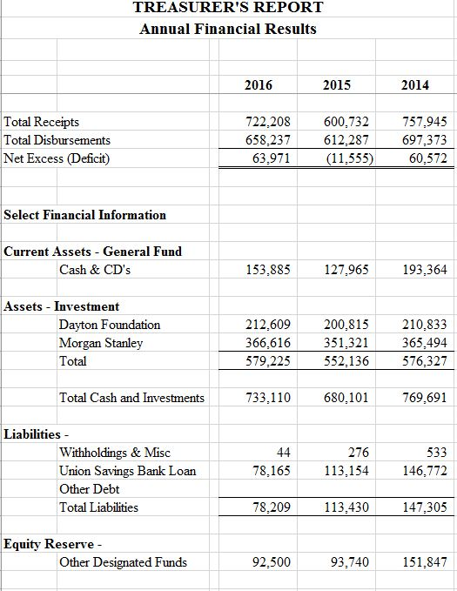
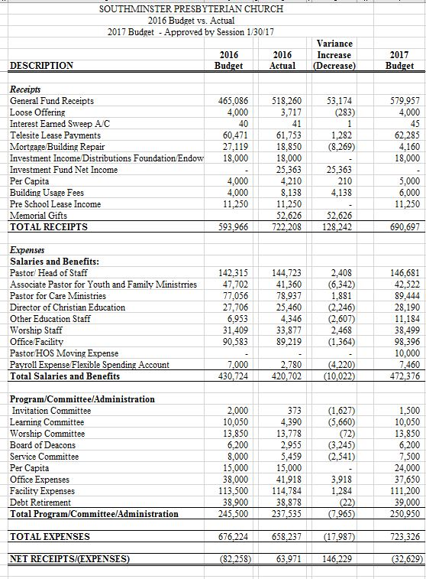
Key Transactions/Activity – 2016

- Through the love of Christ and Southminster, the estate of Nancy Bowlus gifted $52,626 to Southminster.

- Through the generous giving of our members, Southminster has continued to make reductions in the loan that was taken in 2012 to partially fund the Strategic Plan to renovate on the loan totaled $38,878 in 2016. This loan is scheduled to be paid off in January, 2019.

- $2,240 was received in memory of Martha Kienzle, David Lease, Bill Hohenstein and Nancy Bowlus. The Memorial Funds Policy is located in the Church office along with the Memorial Designation form.

- In addition, $50,764 was received from the congregation for pass through items such as designated gifts, mission offerings, flowers, youth events, care, etc.

In Christ – Linda Stephens, outgoing Treasurer
Patty Izor, incoming Treasurer

Communication Team
Submitted by Ken Irwin, Chair

Our Communications Team was formed in June of 2016. We meet the second Thursday of each month.
Our Objective: To create a solid communications plan for both internal and external communications. Once the plan is in place, monitor and make adjustments as necessary.
Members: Stephen Albright, Bill Barlow, Wes Cleaves, Lynn Grubb, Ken Irwin, Steve Plunkett, Linda Wiggers, and Laureen Roe
Accomplishments in 2016:
• Surveyed members on communications effectiveness and issues (Results posted on the web site.)
• Started use of video screen in Sunday services. Documented weekly process and identified volunteers (Laureen).
• Reinstated use of the monitor in the Narthex for announcements.
• Design and approval of a new logo. Copies and templates provided to office staff. Announcements in progress.
• Updated web site with sample video sermon.
• Updated web site with audio from all services in 2016.
• Completed Draft Communications Process Document.
Reach us at communications@sminster.com

PRESBYTERIAN WOMEN OF SOUTHMINSTER
MISSION GIVING - 2016

Hannah’s Treasure Chest $300.00

Canine Companions for Independence 200.00

S.O.A.P. 400.00

Project Blessing 250.00

Artemis House 400.00

The Castle 300.00

Mercy Manor 400.00

VNA / Meals on Wheels 400.00

SPC / Food Pantry 800.00

House of Bread 300.00

Miami Valley Presbytery Pledge 1,302.00

Good Shepherd Ministry 400.00

River of Hope Ministry 500.00

Kirkmont Camp Scholarships Kids 300.00

HOPAC – Randy & Heather Stahley 900.00

Fellowship, Outreach, Nurture Giving

SPC Childcare 400.00

PWS December Lunch 75.00
Pay It Forward 100.00

Blanket Sunday 719.00

Thank Offering 699.00

MEMBERSHIP REPORT

Males Females Total
Total Active Membership, December 31, 2015 211 310 521
Gains:
17 and Under 1 1 2
18 and Over 7 8 15
Total Gains 8 9 17

Losses:
Letter of Transfer or Removal from Rolls 4 6 10
Death 7 4 11
Total Losses 11 10 21

Total Active Membership, December 31, 2016 208 309 517

Age Distribution of Active Members

25 & under 73
26 to 45 99
46 to 55 49
56 to 65 76
66 & over 220

2016 Necrology Report

Died Joined
Don Beal 4-18-16 10-72
Eleanor Bixby (Deacon) 12-26-16 11-13-83
Nancy Bowlus (Ruling Elder and Deacon) 6-23-16 9-27-64
George Fahnline 5-6-16 10-2-11*
Mike Geary 4-6-16 2-14-11*
Bill Hohenstein (Ruling Elder and Deacon) 9-15-16 6-19-94
Martha Kienzle (Ruling Elder and Deacon) 2-24-16 1-26-72
Robert Mays 7-6-16 3-14-76
Beverly McCartney** 12-22-15 1-22-12
Kent Mueller 12-31-16 3-12-78
Robert Skinner 11-25-16 5-20-71

* Rejoined
** Inadvertently omitted in 2015 reporting

SOUTHMINSTER PRESBYTERIAN CHURCH
MINUTES OF ANNUAL CONGREGATIONAL MEETING
FEBRUARY 28, 2016

CALL OF THE MEETING: The congregation of Southminster Presbyterian Church was called together, with proper prior
notice, for the purposes of receiving the Annual Report and electing at large members of the Nominating Committee for 2016.

Moderator Stephen Plunkett opened the meeting with prayer at 11:10 a.m. in the Sanctuary. Over 55 members were
present; a Quorum of the Church’s membership is 52.

BUSINESS OF THE MEETING
The following candidates were put forth to fill the at large Nominating Committee membership for 2016:

Kathy Jester
Bill Barlow
Sarah Albright
Lana Ellinger
Karen Kronson

Hearing no nominations from the floor, it was MSA to close the nominations and to adopt the slate as presented.

It was moved, seconded, and accepted (MSA) to approve the staff reports and the reports of the Board of Deacons, the
Invitation Committee, the Learning Committee, the Service Committee, the Stewardship Committee, and the Worship
Committee and related subcommittees and organizations, as presented.

It was MSA to close the meeting with prayer. Pastor Stephen Plunkett closed the meeting with prayer at 11:27 a.m.

Respectfully submitted,

Andrea Calim, Clerk of Session

SOUTHMINSTER PRESBYTERIAN CHURCH
MINUTES OF ANNUAL CONGREGATIONAL MEETING
August 14, 2016

CALL OF THE MEETING: The congregation of Southminster Presbyterian Church was called together, with proper prior
notice, for the purposes of viewing a short presentation on the Mission Study Report and electing a Pastor Nominating
Committee.

Moderator Stephen Plunkett opened the meeting with prayer at 11:13 a.m. in the Sanctuary. A quorum was present.

BUSINESS OF THE MEETING
Members of the Mission Study Team presented a brief presentation including the new Mission and Vision of Southminster.

The following candidates were put forth to form the Pastor Nominating Committee:

Ralph Adkins
Liz Ferguson
Dorothy Fyffe
Alan Herner
Marj Lawson
Mark Locke
Bob Murphy
Phyllis Strayer
Lois Thorp

Hearing no nominations from the floor, it was MSA to close the nominations and to elect the slate as presented.

It was MSA to close the meeting with prayer. Pastor Stephen Plunkett closed the meeting with prayer at 11:55 a.m.

Respectfully submitted,

Andrea Calim, Clerk of Session

SOUTHMINSTER PRESBYTERIAN CHURCH
MINUTES OF ANNUAL CONGREGATIONAL MEETING
October 30, 2016

CALL OF THE MEETING: The congregation of Southminster Presbyterian Church was called together, with proper prior
notice, for the purposes of electing Elders and Deacons for 2017.

Moderator Stephen Plunkett opened the meeting with prayer at 11:20 a.m. in the Sanctuary. A quorum was present.

BUSINESS OF THE MEETING
The following candidates were put forth to fill Elder and Deacon vacancies for 2017:

Elders:
Class of 2019
Jeff Acred
Jane Barlow
Mark Ferguson
George Lawson
Jeanne Leatherbury
Class of 2018
Chuck Dickerson
Charlie Tapp

Deacons:
Class of 2019
Judy Murphy
Timothy Shaw
Shirley Oglesbee
Sandy Stevens
Barb Adams
Class of 2018
Linda Wiggers
Cheryl Hartman

Hearing no nominations from the floor, it was MSA to close the nominations and to elect the slate as presented.

It was MSA to close the meeting with prayer. Pastor Jackie Nowak closed the meeting with prayer at 11:20 a.m.

Respectfully submitted,

Andrea Calim, Clerk of Session

